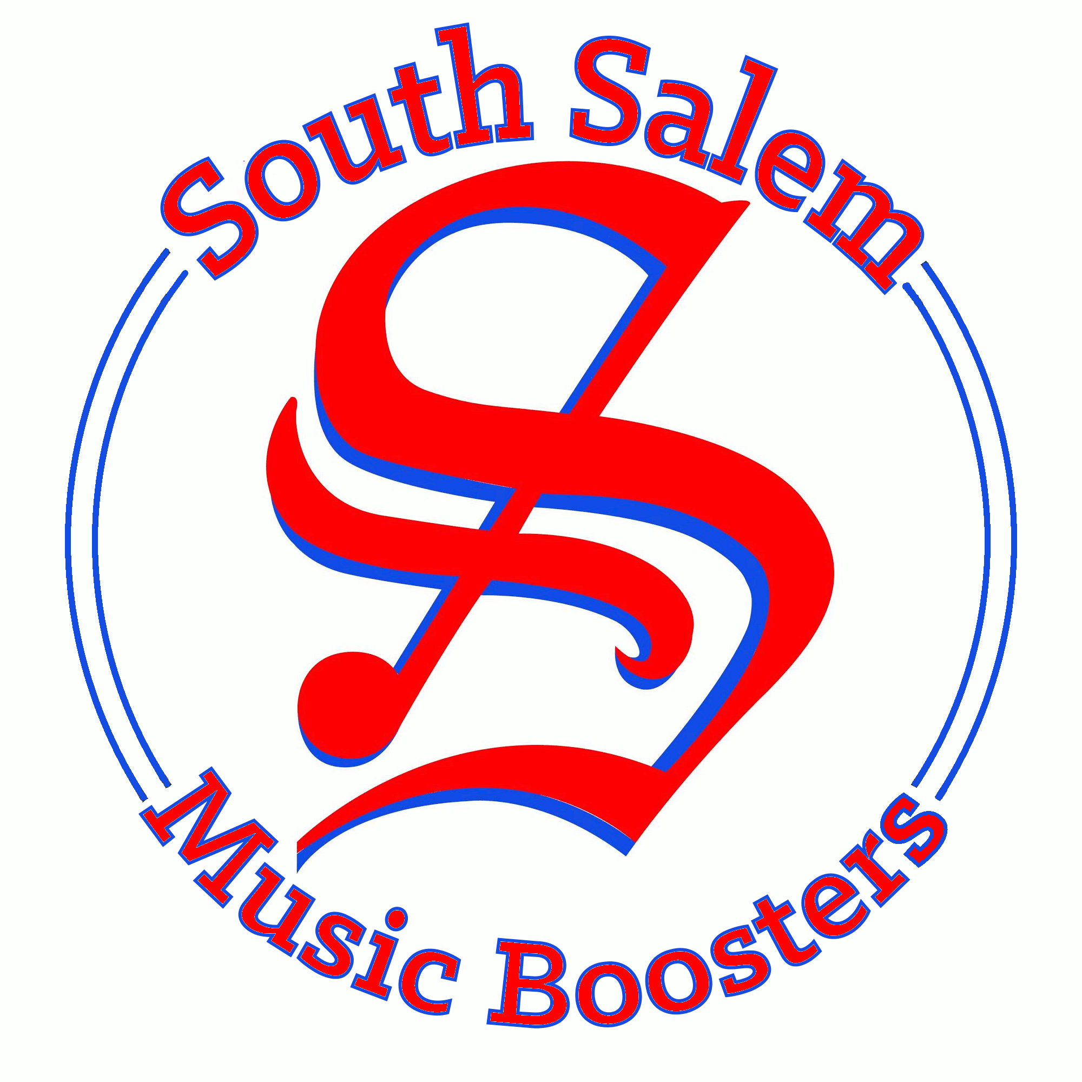 | South Salem High Music Boosters  Parent Volunteer Information Form

Parent Name:
Email:
Contact Phone:
Student Name:
Student Grade:
Student Music Participation: |  | Band  Choir  Orchestra

Please check areas where you can help:

All Programs: | Music Day (Sept) | Flower Basket Sales (May)
 | Pie Sales (Oct/Nov) | Art Fair Parking (July)
 | Wreath Sales (Nov) | Concert Tickets
 | Other:
Band: | Marching Band Uniforms | Chaperone
 | Band Camp Helper | Other:
Choir: | Robe Helper | Other:
 | Chaperone
Orchestra: | Chaperone | Other:

Please complete this form and email it to info@southmusicboosters.org

